DBMS LAB ASSIGNMENT-4

**CH AASEESH SUMANTH**

**19bcs033 T12**

# **Write 5 Nested Queries for your respective database- the queries should not be very similar like just changing the where clause or just building all the queries on only one or two tables etc. The queries should make sense, it should cover most part of your database tables.**

**SQL-QUERY 1)**

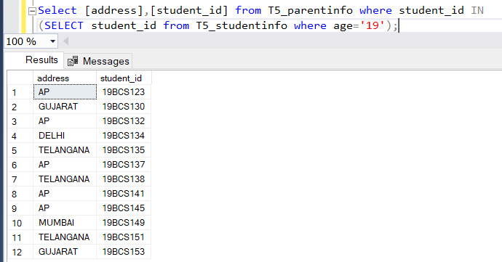

**SQL-QUERY 2)**



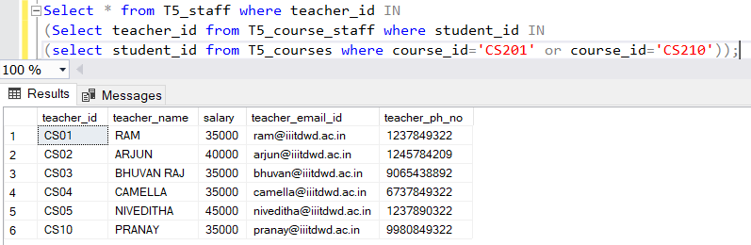

**SQL-QUERY 3)**

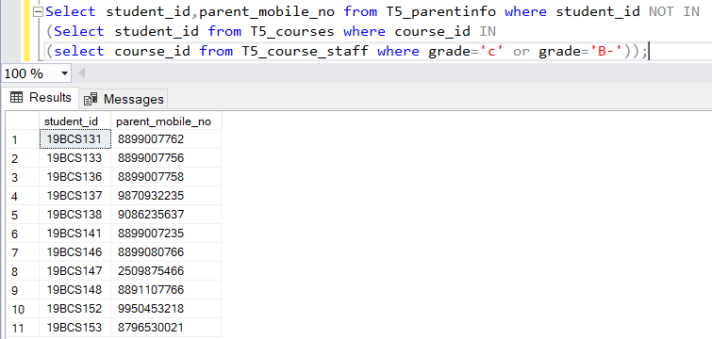

**SQL-QUERY 4)**



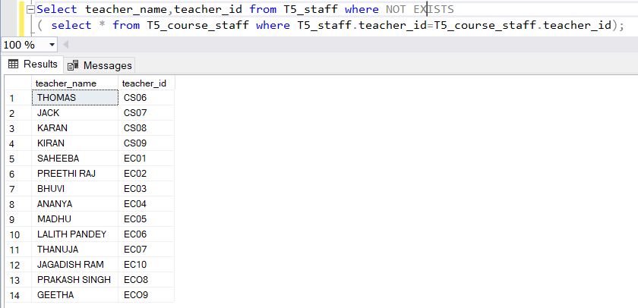

**SQL-QUERY 5)**

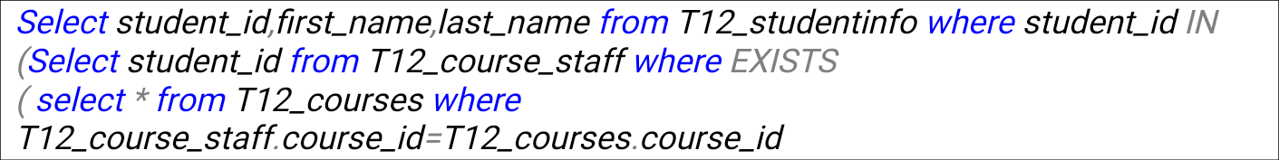

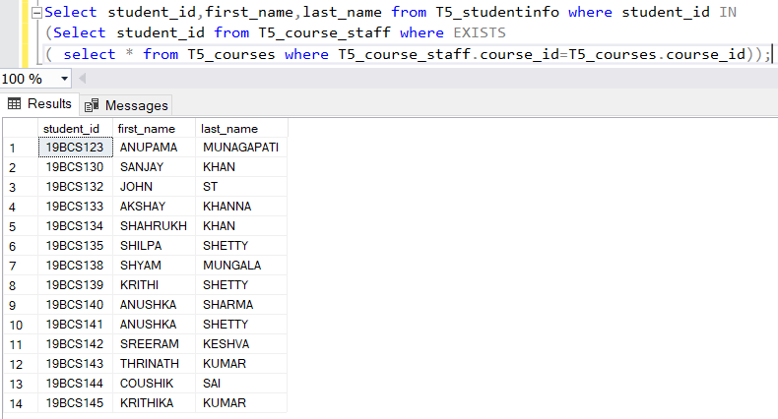

1. **Illustrate how we can use Concat and As operators in SQL (minimum 3 queries)**

**SQL-QUERY 1)**

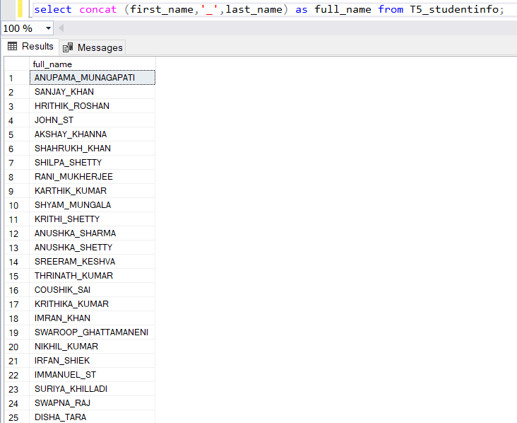

**SQL-QUERY 2)**



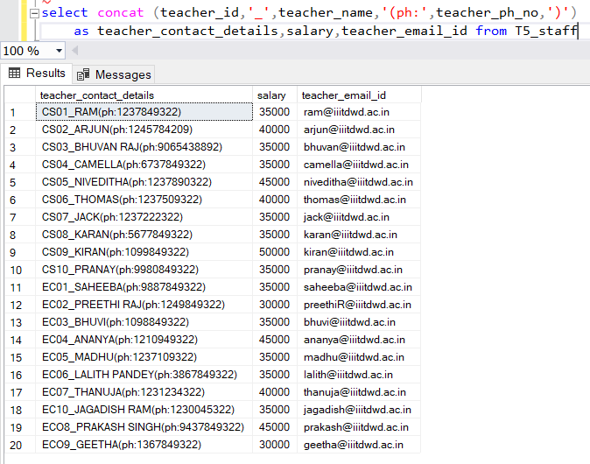

**SQL-QUERY 3)**

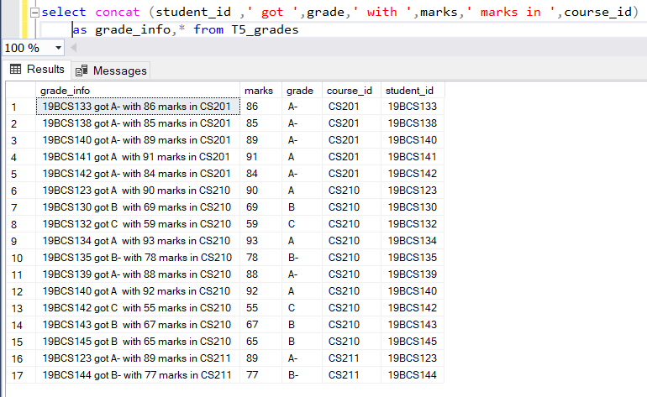

1. **Illustrate all the Comparison operator. FOR ‘>’:**

**SQL-QUERY 1)**

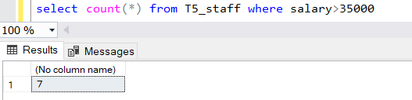

**SQL-QUERY 2)**



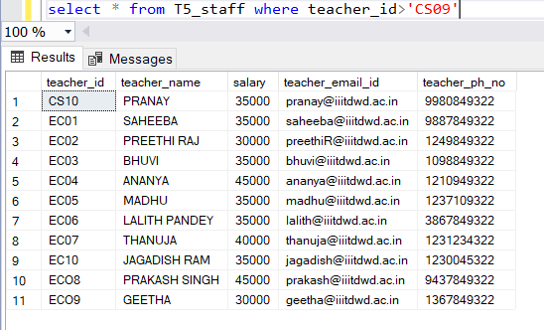

**FOR ‘<’: SQL-QUERY1)**

****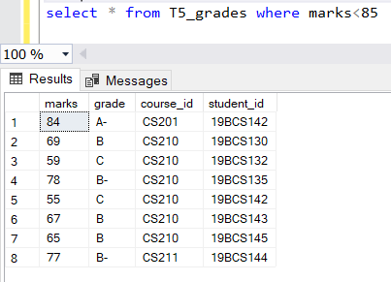

**SQL-QUERY 2)**



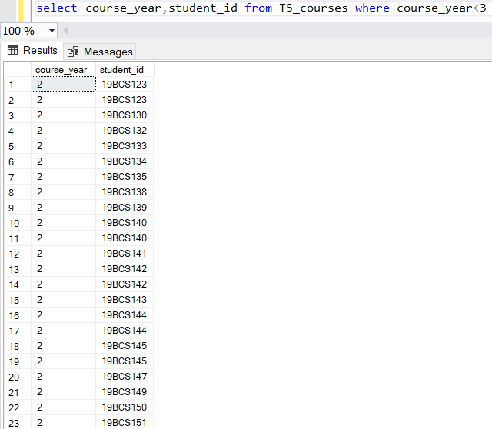

**FOR ‘>=’: SQL-QUERY 1)**

****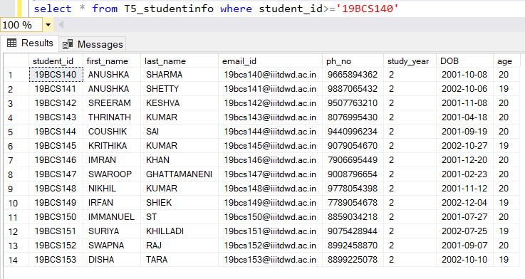

**SQL-QUERY 2)**



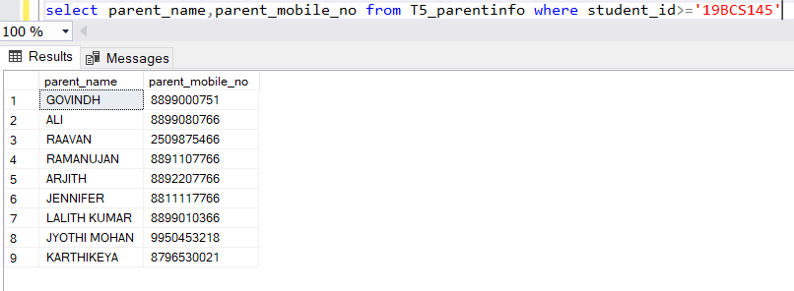

**FOR ‘<=’: SQL-QUERY 1)**



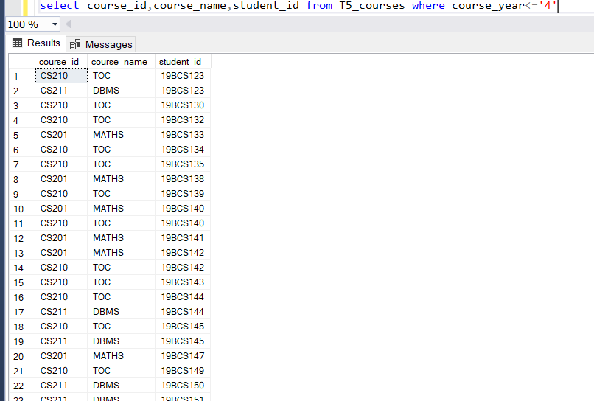

**SQL-QUERY 2)**



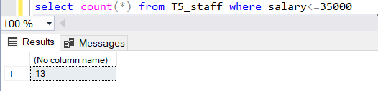

**SQL-QUERY 1)**



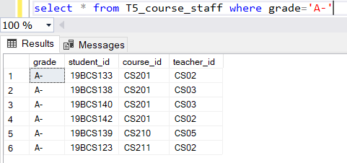

**SQL-QUERY 2)**

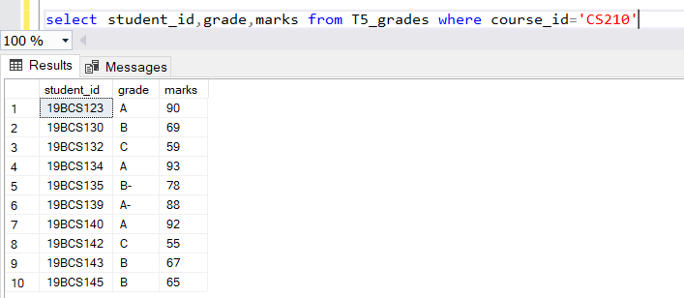

**FOR ‘<>’: SQL-QUERY 1)**

****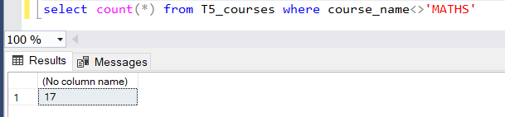

**SQL-QUERY 2)**

****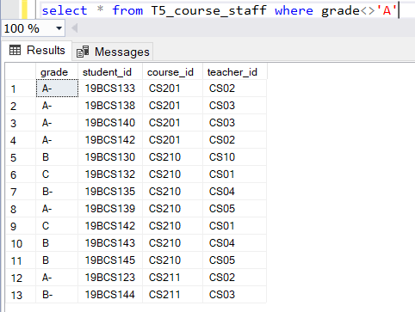

1. **Illustrate Logical operators except ANY, ALL and Like (2 queries for each operator)**

**OR OPERATOR:**

**QUERIES:**

**i)**



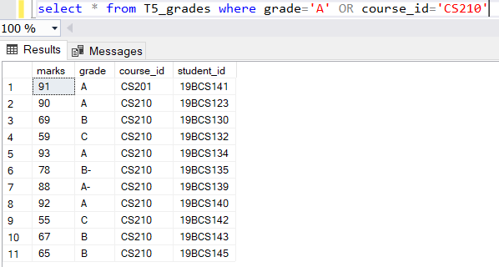

**ii)**



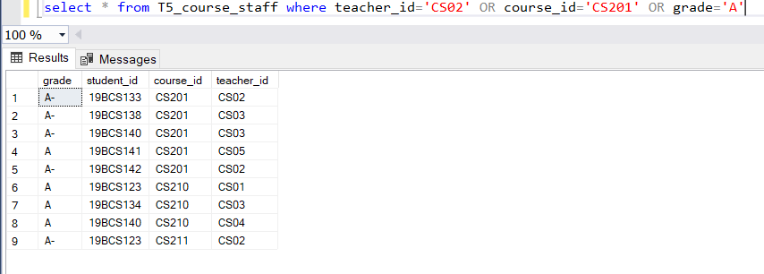

**iii)**



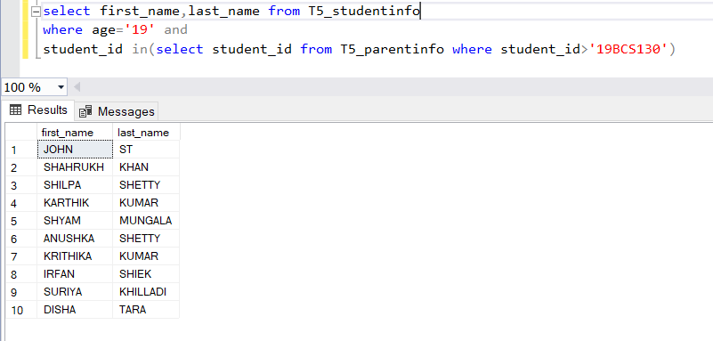

**iv)**



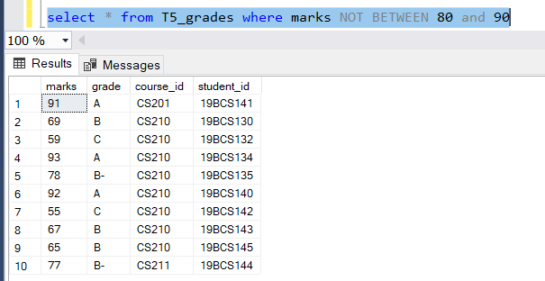

**v)**



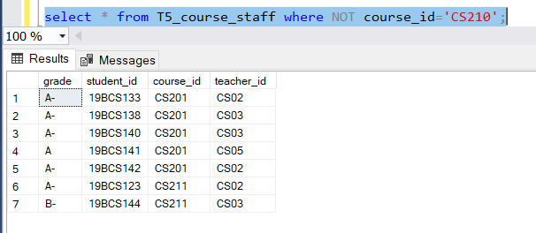

**vi)**



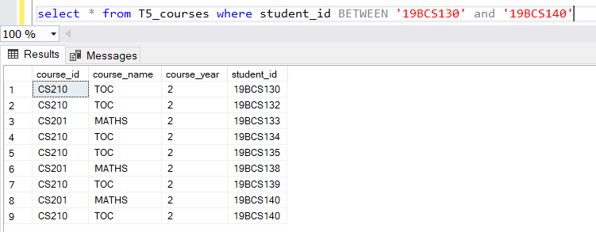

**vii)**



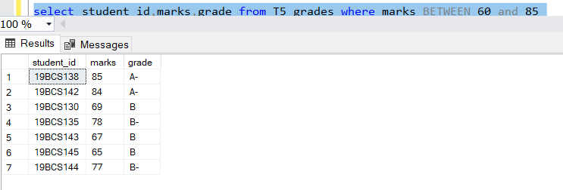

**viii)**



